Press Release For immediate release

Dritev
Kongresshaus Baden-Baden, Germany
June 12 to 13
Stand 53

Battery Show Europe
Messe Stuttgart, Germany
June 18 to 20
Hall 9, booth C67

Trelleborg Presents e-Mobility Solutions
at Dritev and The Battery Show

Trelleborg Sealing Solutions showcases its e-mobility solutions at two major events in the automotive calendar in June, The Battery Show Europe from June 18 to 20 and Dritev from June 12 to 13.
At both events, Trelleborg will feature the three-layer Rubore® Washer, the automated fiber placement (AFP) process for rotor sleeves and the radial shaft seal HiSpin® EV.
Ahead of the Battery Show Europe, Björn Scherbaum, Head of Account Management & Sales Development Engineering at Trelleborg Sealing Solutions, says: "The event is an opportunity for us to present our extensive portfolio of solutions for highly efficient electric motors and battery systems for the automotive industry. Polymer-based seals and components often offer significant advantages over metal in terms of performance enhancement, weight reduction or corrosion protection of applications."
Guillaume Carron, Business Development Engineer Automotive at Trelleborg Sealing Solutions, highlights the collaborative value of the Dritev Congress: “We will exchange ideas with engineers and decision-makers in the field of powertrains and transmissions. In particular, we will demonstrate Trelleborg’s key technologies for the automotive industry using practical examples and provide our customers with application scenarios that demonstrate our innovative solutions," he says.
The Rubore® Washer is highly efficient at sealing and protecting sensitive electrical systems from moisture and corrosion, enabling customers to increase the performance, safety and longevity of their vehicles. It is manufactured using a special production process in which the carrier metal is vulcanized with a rubber layer on both sides, creating a three-layer laminate that is durable and particularly long-lasting. The washer is available in different diameters and thicknesses to meet manufacturers’ requirements.
Trelleborg will also demonstrate its innovative AFP process for the rotor sleeves of electric motors. It allows thermoplastic fiber composite sleeves to be wrapped directly around rotors in a fully automated process, resulting in thinner sleeves compared to conventional epoxy solutions. Thanks to the thermoplastic in-situ consolidation, no additional use of an autoclave is required. This enables customers to utilize a rapid, high-quality manufacturing process to profitably produce large quantities of electric motors with increased performance and efficiency.
Also showcased at the events is the new radial shaft seal HiSpin® EV. Thanks to its symmetrical design, it offers excellent sealing performance for both directions of shaft rotation in electric motors. The seal is designed for shaft surface speeds of up to 40 meters per second/131 feet per second, and has low friction properties, significantly reducing heat generation at high rotational speeds.

For more on the Battery Show Europe 2024:
https://www.thebatteryshow.eu/en/Home.html
For more on Dritev:
https://www.vdiconference.com/dritev/

-ends-

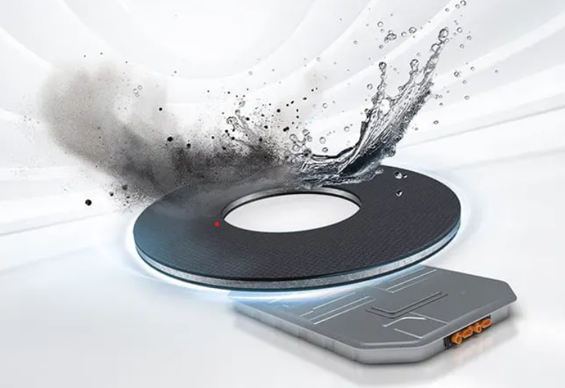

Caption: The Rubore® Washer from Trelleborg Sealing Solutions provides leak-proof sealing protection for screws to efficiently shield critical systems in electric vehicles. Photo: Trelleborg Sealing Solutions

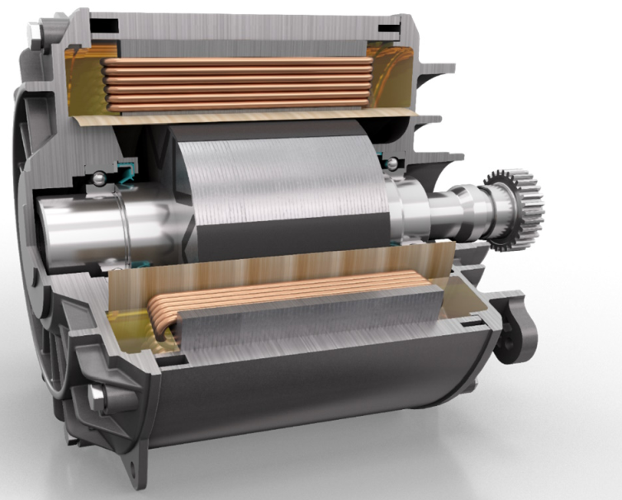

Caption: Trelleborg Sealing Solutions presents its AFP technology at the Battery Show Europe, allowing rotor sleeves made of thermoplastic fiber composites to be wrapped around rotors in a fully automated process. Photo: Trelleborg Sealing Solutions. Photo: Trelleborg Sealing Solutions

For further details:
Paul Ravenscroft
PR & Content Development Manager
Tel: +44 (0) 7890 419312
Email: paul.ravenscroft@trelleborg.com

About Trelleborg Sealing Solutions and Trelleborg Group
Trelleborg Sealing Solutions is one of the world’s leading developers, manufacturers and suppliers of precision seals, bearings and custom-molded polymer components. It focuses on meeting the most demanding needs of aerospace, automotive, healthcare & medical and general industrial customers. The company’s global network encompasses over 40 production facilities, more than 60 Customer Solution Centers, more than 15 R&D centers and a Customer Innovation Center. It accelerates the progress of its customers through outstanding local support, an unrivalled product range including patented products and proprietary materials, a portfolio of established brands, unique process offerings, its ServicePLUS value chain solution and ‘Ease of Doing Business’ philosophy.www.trelleborg.com/seals
Trelleborg is a world leader in engineered polymer solutions that protect critical applications in demanding environments. Its innovative solutions accelerate performance for customers in a sustainable way. In 2023, the Trelleborg Group had annual sales of approximately SEK 34 billion in around 40 countries. The Group comprises three business areas: Trelleborg Industrial Solutions, Trelleborg Sealing Solutions and Trelleborg Medical Solutions. The Trelleborg share has been listed on the Stock Exchange since 1964 and is listed on Nasdaq Stockholm, Large Cap. www.trelleborg.com

