Press release For immediate distribution
Stefa® HiSpin® EV40: A Pioneering Precision-Engineered
Seal for High-Speed Electric Motors

Trelleborg Sealing Solutions launches the Stefa® HiSpin® EV40, an innovative elastomer radial shaft seal equipped with proprietary technology and engineering to meet the demands of modern electric vehicle (EV) motors.

Designed to operate at high surface speeds, it sets a new technology standard, providing superior low-friction sealing while offering exceptional performance and durability for EV applications.

In today’s rapidly advancing automotive landscape, electric vehicles are pushing the limits of engineering, with traction motors reaching speeds of up to 20,000 rpm. As manufacturers strive to optimize efficiency and power density, the need for reliable and efficient sealing solutions has never been greater. The Stefa® HiSpin® EV40 addresses these challenges head-on with cutting-edge technology and superior engineering.

At the heart of the Stefa® HiSpin® EV40 is a technological breakthrough: Trelleborg’s proprietary Phase-Shifted-Wave (PSW) technology. By actively pumping fluid back to the oil side during shaft rotation, this patented innovation ensures superior sealing performance even in highly lubricated conditions. The design delivers consistent sealing efficiency while it reduces radial force, decreasing friction and improving powertrain efficiency.

“This patented hydrodynamic feature consists of multiple grooves with single-sided waviness, separated by static bands,” explains Nino Dakov, Manager Technology Engineering at Trelleborg Sealing Solutions.

“The shifted waviness between neighboring grooves enables gradual back-pumping from the air to the oil side. This innovative design is the result of finite element analysis, examining the seal assembly across different sizes.”

The seal’s symmetrical design simplifies customer validation, and no additional testing is required for the lower-performing direction. In terms of part management, the seal operates equally effectively in either direction so can be employed easily across multiple EV applications.
The Stefa® HiSpin® EV40 has undergone rigorous testing to validate its superior performance and durability. In a high-speed endurance test, the seal maintains flawless operation at speeds of 20,130 rpm (equivalent to 40 m/s/131 f/s) over a period of 240 hours, without any signs of leakage or wear. An additional 1,000-hour endurance test has demonstrated the seal’s resilience under demanding conditions, confirming its ability to withstand extreme speeds and temperatures without compromising integrity.
The seal’s specially formulated fluorocarbon (FKM) material also has proven compatibility with various electric axle fluids, while its design makes it well suited for high-volume production. Engineered to accommodate shaft run out, the Stefa® HiSpin® EV40 ensures outstanding sealing efficiency under diverse lubrication conditions, resulting in reliable, long-lasting performance.
As the automotive industry transitions from traditional internal combustion engines (ICEs) to electric mobility, manufacturers face unprecedented challenges. “Historically, automotive development has been an evolutionary process focused on incremental improvements. The shift to EVs, however, demands a complete rethinking of components and performance metrics,” says Guillaume Carron, Business Development Engineer at Trelleborg Sealing Solutions.
With this new product, Trelleborg Sealing Solutions is poised to highlight the importance of developing solutions from the ground up rather than relying on conventional approaches: “We conducted in-depth research to analyze market needs and define the development scope for EV traction motor radial shaft seals. This process involved filtering out niche requirements that could lead to unnecessary overengineering,” adds Carron.
Trelleborg Sealing Solutions continues to lead the way in developing forward-thinking solutions tailored for the electric vehicle market. By leveraging decades of expertise and focusing on the specific challenges of EV applications, Trelleborg demonstrates its commitment to advancing mobility and sustainability.
“The Stefa® HiSpin® EV40 exemplifies our strategy of engineering from the ground up to optimize performance while minimizing complexity and cost. By adopting a holistic approach to product development, we ensure that our solutions are both practical and innovative,” concludes Carron.
Find out more: https://www.trelleborg.com/en/seals/products-and-solutions/latest-innovations/latest-innovations/stefa-hispin-ev
-ends-

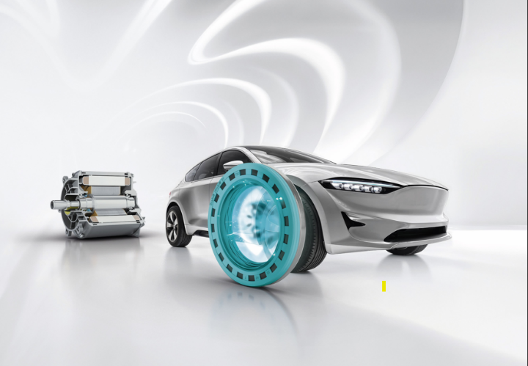

Caption: Trelleborg Sealing Solutions launches the Stefa® HiSpin® EV40, an innovative elastomer radial shaft seal equipped with proprietary technology and engineering to meet the demands of modern electric vehicle EV motors. Credit: Trelleborg Sealing Solutions

For more information, please contact:
Paul Ravenscroft
Tel: +44 (0) 7890 419312
Email: paul.ravenscroft@trelleborg.com

Trelleborg Sealing Solutions is one of the world’s leading developers, manufacturers and suppliers of precision seals, bearings and custom polymer components. It focuses on meeting the most demanding needs of aerospace, automotive and general industrial customers. The company’s global network encompasses over 35 production facilities, 55-plus Customer Solution Centers, 15 R&D centers and two Innovation Centers. It accelerates the progress of its customers through outstanding local support, an unrivalled product range including patented products and proprietary materials, a portfolio of established brands, unique process offerings, its ServicePLUS value chain solution and ‘Ease of Doing Business’ philosophy.www.trelleborg.com/seals
Trelleborg is a world leader in engineered polymer solutions that protect critical applications in demanding environments. Its innovative solutions accelerate performance for customers in a sustainable way. In 2023, the Trelleborg Group had annual sales of approximately SEK 34 billion in around 40 countries. The Group comprises three business areas: Trelleborg Industrial Solutions, Trelleborg Sealing Solutions and Trelleborg Medical Solutions. The Trelleborg share has been listed on the Stock Exchange since 1964 and is listed on Nasdaq Stockholm, Large Cap. www.trelleborg.com

